**Vietnam General Confederation of Labor**

**TON DUC THANG UNIVERSITY**

**FACULTY OF INFORMATION TECHNOLOGY**



**FINAL REPORT**

**Requirements Analysis & Design (RAD)**

*Instructor*: **Mr.PHẠM THÁI KỲ TRUNG**

*Student*: **PHAN THÀNH ĐẠT - 521H0218**

**PHẠM TRẦN TIẾN PHÁT- 521H0285**

*Class* :**21H50302**

*Year* **: 2023-2024**

**HO CHI MINH CITY, 2023**

Vietnam General Confederation of Labor

**TON DUC THANG UNIVERSITY**

**FACULTY OF INFORMATION TECHNOLOGY**



**FINAL REPORT**

**Requirements Analysis & Design (RAD)**

*Instructor*: **Mr. PHAM THAI KY TRUNG**

*Student*: **PHAN THÀNH ĐẠT - 521H0218**

**PHẠM TRẦN TIẾN PHÁT- 521H0285**

*Class* :**21H50302**

*Year* **: 2023-2024**

**HO CHI MINH CITY, 2023**

ACKNOWLEDGEMENT

I would like to express my deep gratitude to Mr. Phạm Thái Kỳ Trung for his valuable support in the past project. The teacher's knowledge and guidance have played an important role in our work process. What he shared and guided us helped us overcome challenges, expand our knowledge and approach the project more confidently. His dedication and help not only helped us understand the project better, but also encouraged and inspired us.

*Ho Chi Minh city, 26th December, 2023*

*Author*

*(Sign and write full name)*

*Phan Thành Đạt*

*Phạm Trần Tiến Phát*

CONFIRMATION AND ASSESSMENT SECTION

**Instructor confirmation section**

_______________________________________________________________________________________________________________________________________________________________________________________________________________________________________________________________________________________________________________________________________________________________________________________________________________

*Ho Chi Minh 26th December, 2023*

*(Sign and write full name)*

**Evaluation section for grading instructor**

_______________________________________________________________________________________________________________________________________________________________________________________________________________________________________________________________________________________________________________________________________________________________________________________________________________

*Ho Chi Minh, 26th December 2023*

*(Sign and write full name)*

**THE PROJECT IS COMPLETED**

**AT TON DUC THANG UNIVERSITY**

Our team would like to assure that this is our own research project and is under the scientific guidance of Pham Thai Ky Trung Teacher. The research content and results in this topic are honest and have not been published in any form before. The data in the tables for analysis, comments, and evaluation were collected by the author from different sources and clearly stated in the reference section.

In addition, the report also uses a number of comments, assessments as well as data from other authors and other organizations, all with citations and source notes.

**If any fraud is detected, our team will take full responsibility for the content of our IT Project Report 2.** Ton Duc Thang University is not involved in copyright violations caused by us during the implementation process (if any).

*Ho Chi Minh city, 22th December, 2023*

*Author*

*(Sign and write full name)*

*Phan Thành Đạt*

*Phạm Trần Tiến Phát*

INDEX

**EXECUTIVE SUMMARY 6**

**CHAPTER 1: BUSINESS REQUIREMENTS 7**

1.1 Organization Chart / Project Chart / Gantt Chart 7

1.2 Business Processes / Flowchart of Requirements 8

1.3 Activity Diagrams 9

1.4 List of Requirement 10

**CHAPTER 2: System Requirements Analysis 11**

2.1 Translate from Business Use Case 11

2.1.1 System Narrative 11

2.1.2 Users and their goals 11

2.1.3 List of Events 12

2.1.4 List of Actors 12

2.1.5 List of Use Cases 13

2.1.6 Use Case Diagrams 16

2.1.7 Domain Class Model Diagram 17

2.2 Use Case Descriptions 18

2.2.1 Use Case : Create new Customers 18

2.2.2 Use Case: View Customer 20

2.2.3 Use case: View Product List 22

2.2.4 Use case: Add new product. 24

2.3 Verifying use cases for actor 28

2.3.1 Verifying use cases: Manage Customer for Sale Staff. 28

2.3.2 Verifying use cases: Manage Product for Store Admin. 28

**CHAPTER 3: System Requirements Design 29**

3.1 Design Class for Management Customer. 29

3.1.1 Design Class in Detailed Design. 29

3.1.2 Design Class Diagram 30

3.1.3 OOD with Communication 32

3.1.4 OOD with Sequence Diagram 33

3.1.5 Final Design Class Diagram 33

3.2 Design Class for Product Management 34

3.2.1 Design Classes in Detailed Design 34

3.2.2 Design Class Diagram 35

3.2.3 OOD with Communication 37

3.2.4 OOD with Sequence Diagram 38

3.2.5 Final Design Class Diagram 38

**CHAPTER 4: System Requirements Implementation 40**

4.1 Design Class for Sub-System 40

4.2 Package Diagram for Sub System 40

4.3 Implementation 41

4.3.1 Map persistent objects to the tables in a database 41

4.3.2 Modifying sequence diagrams 44

4.3.3 UI Design 47

4.3.3.1 UI Desgin for use case: Manage Customers 47

4.3.3.2 Use Case: Management Product. 49

4.3.4 SQL Code 50

4.3.5 Software Classes Method Code. 53

**CHAPTER 5: System Testing, Deployment and Demonstration. 55**

5.1 Testing: Test plan & Test case 55

5.2 Deployment 56

5.3 Demonstration 58

**CHAPTER 6: Conclusions/ Recommendations 59**

EXECUTIVE SUMMARY

The purpose of this document is to provide an overview of the proposed system for B2B Information Systems catered towards Agents’ Retail Stores. This system intends to introduce a comprehensive Point-of-Sale website offering a range of management functionalities. Encompassing Account, Product, Customer, Sales, Inventory Management, and Reporting tools, this system aims to streamline operations, ensuring efficient account handling, seamless product management, customer-centric approaches, effective sales tracking, meticulous inventory control, and insightful reporting capabilities. Role-based access control ensures tailored access, empowering retail store agents while furnishing the company with crucial oversight across its retail network.

**CHAPTER 1: BUSINESS REQUIREMENTS**

* 1. **Organization Chart / Project Chart / Gantt Chart**

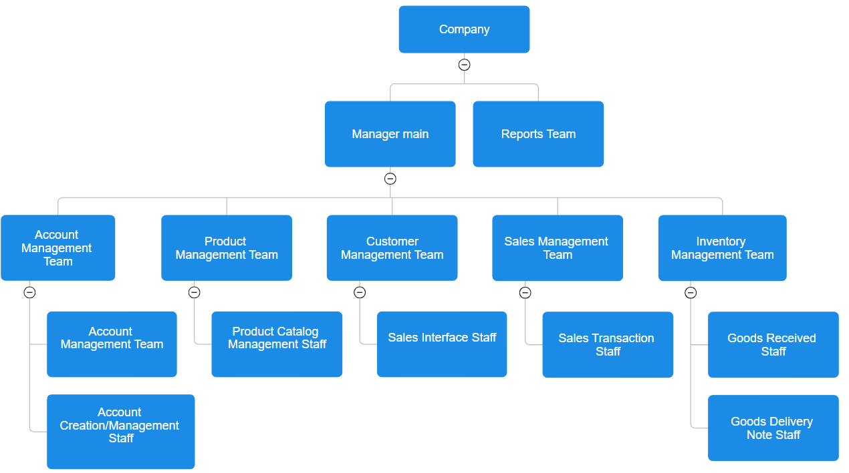

**Organization Chart**

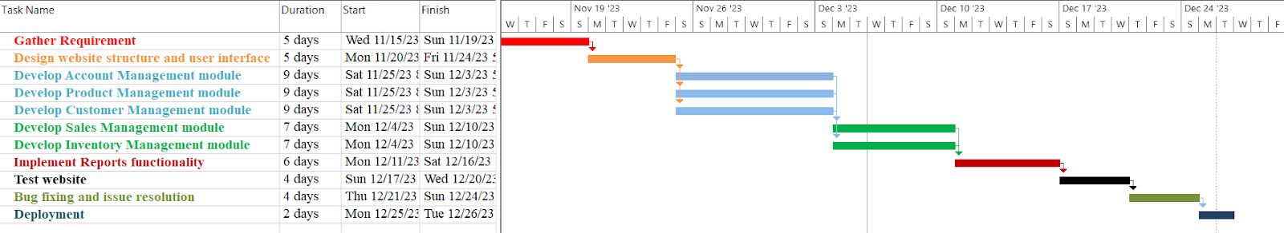

**Gantt Chart**

* 1. **Business Processes / Flowchart of Requirements**

*Business processes to manage customers when their account is created:*

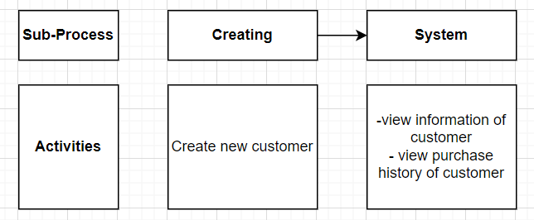

**Figure 3.1: Business Processes**

*Business processes to manage the product when it is created:*

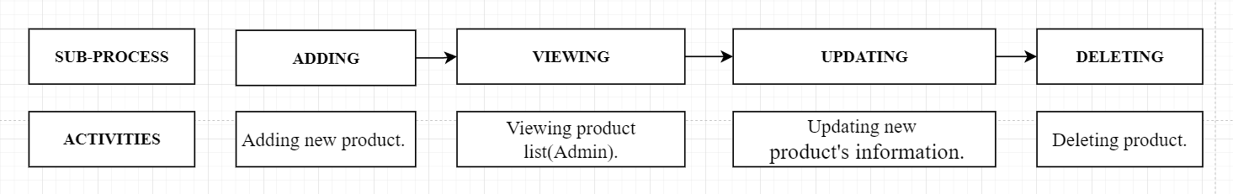

**Figure 3.2: Business Processes**

* 1. **Activity Diagrams**

*Activity Diagram to manage the customers when their account is created:*

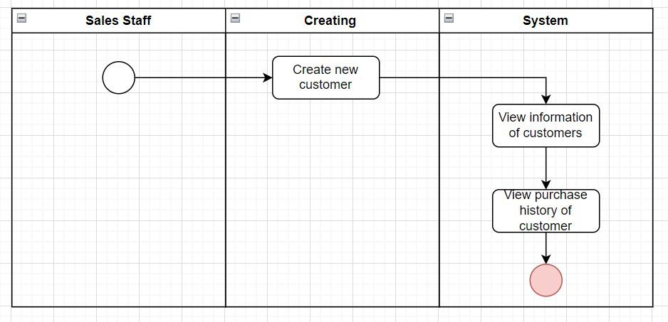

**Figure 4.1: Activity Diagram**

*Activity Diagram to manage the product when it is created:*

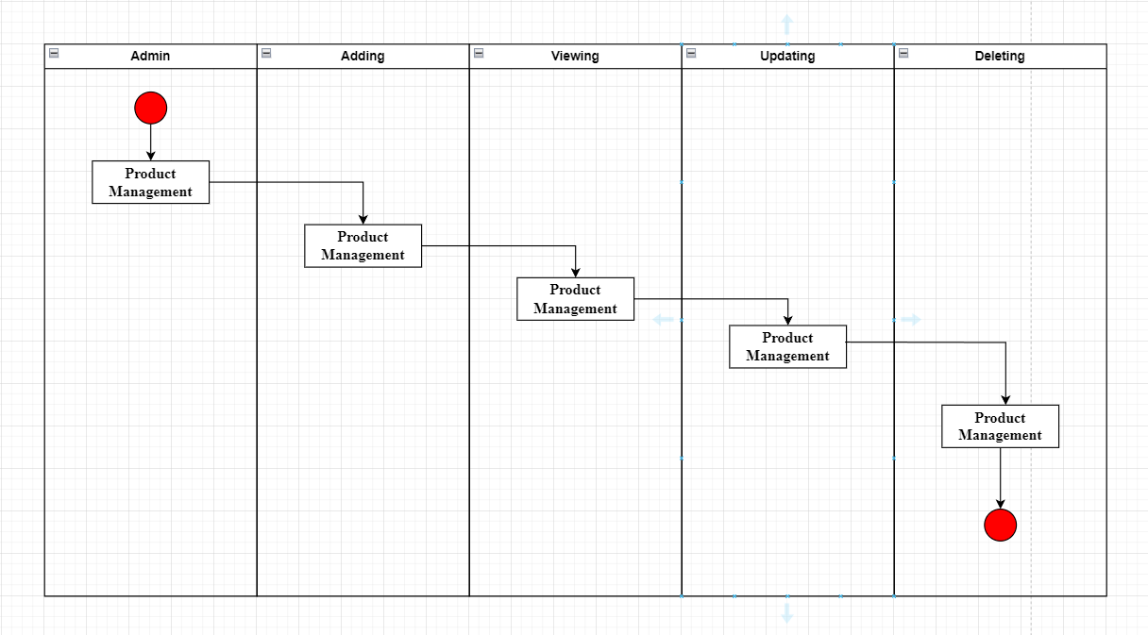

**Figure 4.2: Activity Diagram**

* 1. **List of Requirement**

|  |  |  |
| --- | --- | --- |
| **Requirements** | **Functional** | **Non-Functional** |
| The system shall allow the creation of an Admin account for each agent's retail store. | x |  |
| The system shall enable administrators to view, add, update, and delete products. | x |  |
| The system should facilitate the creation of new customer profiles through the Sales interface for initial purchases. | x |  |
| The system shall support the management of sale transactions for each agent's retail store, including receipts and reports. | x |  |
| The system must allow the management of the overall inventory across all agent retail stores. | x |  |
| The system should generate comprehensive reports for both the company and individual agents' retail stores. | x |  |
| The system should implement robust security measures to protect sensitive data like customer information and financial records. |  | x |
| The system should be able to handle a large volume of transactions without significant performance degradation. |  | x |
| The system's interface should be intuitive and user-friendly for different roles (Admins, Sales Staff) with features relevant to each role easily accessible. |  | x |
| The system should be scalable to accommodate the addition of new agent retail stores without a significant impact on performance. |  | x |

**CHAPTER 2: System Requirements Analysis**

**2.1 Translate from Business Use Case**

***2.1.1 System Narrative***

B2B System for Outlet Retail Stores is a comprehensive POS website that supports the management of important functions such as account management, products, customers, sales, and inventory management. Allows creating admin accounts, managing products with detailed information, managing customers and purchase history, tracking sales transactions of each store, and managing inventory. The system provides overview reports for the company and each store to support management and strategic decision making.

**2.1.2 *Users and their goals***

|  |  |
| --- | --- |
| **USER/ACTOR** | **USER GOAL AND RESULTING USE CASE** |
| Company Admin | CRUD store Admin Account  CRUD Product  View total sale of company  Manage the inventory  Add Goods Received Note  Add Goods Delivery Note  View reports |
| Store Admin | CRUD Staff account  View product listings  Manage Sale transactions  View reports |
| Sales Staff | View products listing (Sales Staff)  Add new customer  View customers' personal information  View customer’s purchase history |

***2.1.3 List of Events***

|  |  |  |  |  |  |
| --- | --- | --- | --- | --- | --- |
| **EVENT** | **TRIGGER** | **SOURCE** | **USE CASE** | **RESPONSE** | **DESTINATION** |
| Create Admin Account | Company Admin initiates the creation of a new admin account. | Admin | Manage Store Admin Account | New admin account created successfully. | Admin account database or system. |
| View Total Sales | Company Admin requests to view total sales figures. | Admin | View Total Sale | Display of total sales statistics. | Admin's interface or reporting system. |
| Create Product | Company Admin adds a new product to the inventory. | Admin | Manage Product | New product added to the inventory. | Inventory database or product management system. |
| Process Sale | Store Admin manages a sales transaction. | Store Admin | Manage Sale Transactions | Successful completion of the sales transaction. | Sales transaction records or accounting system. |
| View Products | Store Admin accesses the list of available products. | Store Admin | View Product Listings | Display of the product inventory. | Store Admin interface. |
| Create Customer Profile | Sales Staff adds a new customer's information | Sales Staff | Add New Customer | Customer profile successfully created. | Customer database or CRM system. |
| Read Purchase History | Sales Staff checks a customer's purchase history. | Sales Staff | View Customer’s Purchase History | Display of the customer's purchase records. | Sales Staff interface or CRM system. |

***2.1.4 List of Actors***

**Admin:** takes on the role of overall system management, providing and managing administrative accounts for each retail outlet store. Their main responsibility is to ensure account management for each employee at retail stores, and is also responsible for the overall management of the system, including activities such as sales management, inventory warehouse and customer information.

**Store Admins:** are specific managers in each store. Their duties are to create and manage accounts for store employees, as well as maintain detailed information about products, customers, sales transactions, and inventory management at their stores to ensure operation went smoothly.

**Sales Staff:** performs direct sales and creates new customer information through the sales interface. While providing customer service and conducting sales transactions, they have limited access to general system and product information, focusing primarily on interacting and serving customers effectively fruit.

***2.1.5 List of Use Cases***

**Use Case for Admin:**

*Manage Store Admin Account*

+Create Admin Account: Create a new admin account.

+Read Admin Account: View admin account information.

+Update Admin Account: Modify admin account details.

+Delete Admin Account: Remove an admin account.

*Manage Product:*

+Create Product: Add a new product to the inventory.

+Read Product: Access and view the list of products.

+Update Product: Edit product information.

+Delete Product: Remove a product from the inventory.

*View Total Sale*

+View Total Sales: Access the company's total sales figures.

*Manage Inventory*

+Add to Inventory: Add items to the inventory.

+Remove from Inventory: Remove items from the inventory.

*Manage Goods Received Note*

+Create Goods Received Note: Generate notes for received goods.

+Read Goods Received Note: Access details of goods received.

*Manage Goods Delivery Note*

+Create Goods Delivery Note: Generate notes for goods delivery.

+Read Goods Delivery Note: Access details of goods delivered.

*View Reports*

+Generate Reports: Create and view reports regarding sales, inventory, etc.

**Use Case for Store Admin:**

*Manage Staff Account*

+Create Staff Account: Add a new staff member's account.

+Read Staff Account: Access and view staff account details.

+Update Staff Account: Modify staff account information.

+Delete Staff Account: Remove a staff member's account.

*View Product Listings*

+View Products: Access and view the list of available products.

*Manage Sale Transactions*

+Process Sale: Handle and process sales transactions.

*View Reports*

+View Sales Reports: Access reports related to sales figures.

**Use Case for Sales Staff:**

*View Product Listings*

+ View Products: Access and view the available products.

*Add New Customer*

+ Create Customer Profile: Record information for a new customer.

*View Customer Information*

+ Read Customer Profile: Access and view individual customer details.

*View Customer’s Purchase History*

+ Read Purchase History: Access and view the history of a customer's purchases.

***2.1.6 Use Case Diagrams***

The use case diagram of Customer Management System:

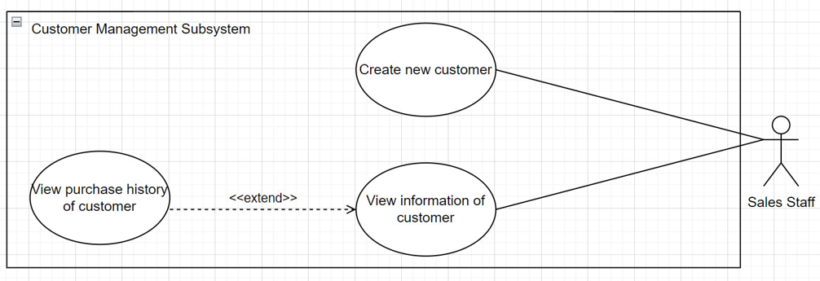

The use case diagram of Product Management  System:

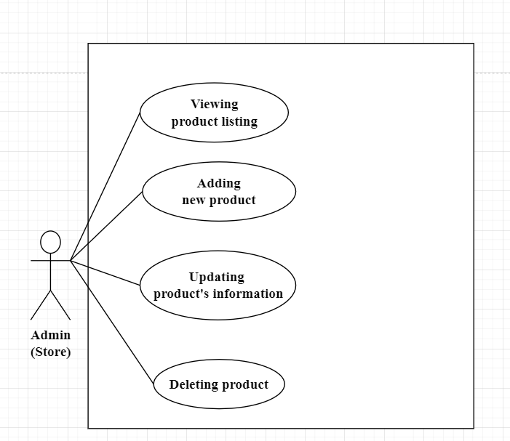

***2.1.7 Domain Class Model Diagram***

Domain Class Model Diagram of Manage Customer System:

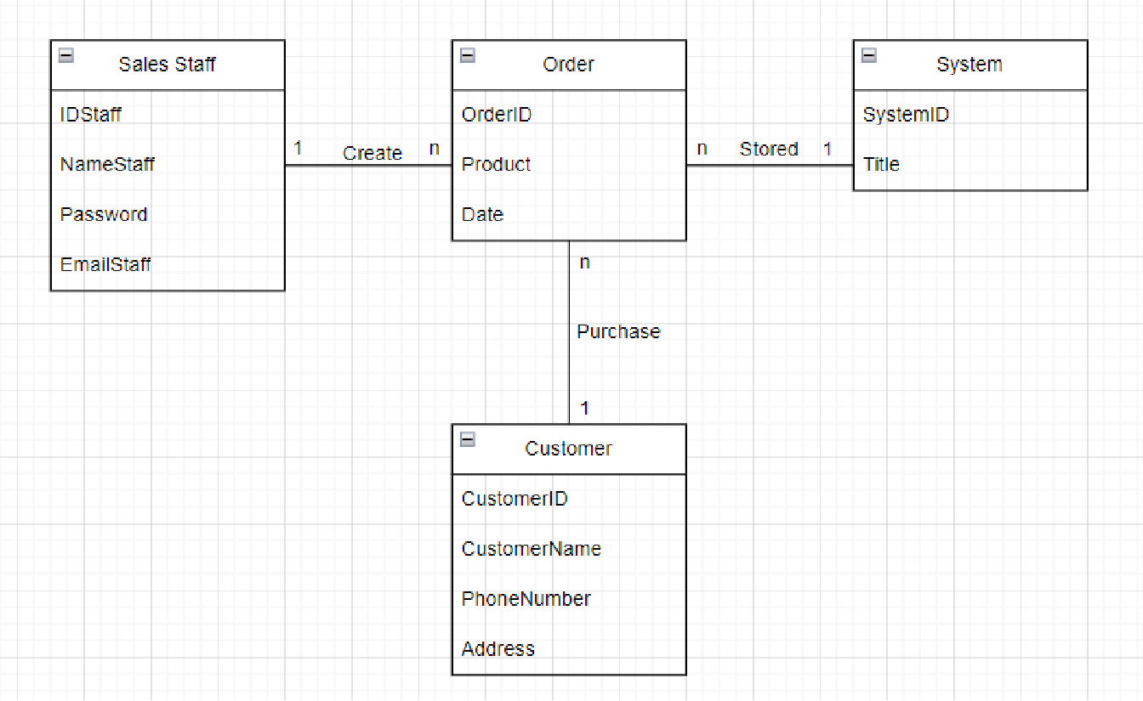

Domain Class Diagram for manage product

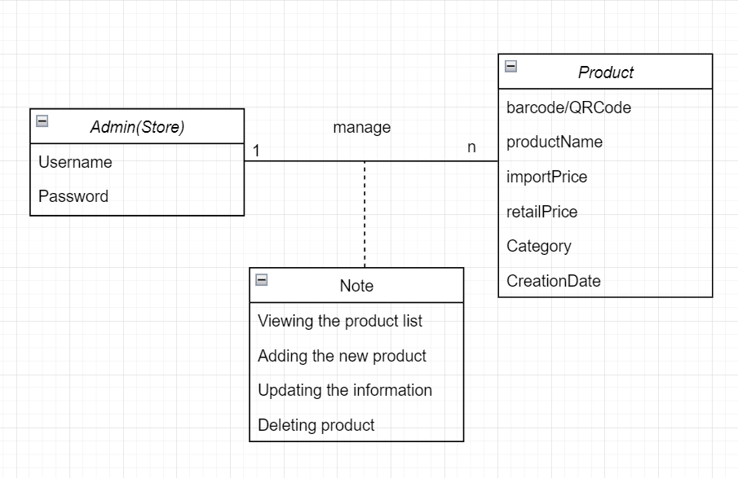

***2.2 Use Case Descriptions***

***2.2.1 Use Case : Create new Customers***

**I . Use Case : Create new customers**

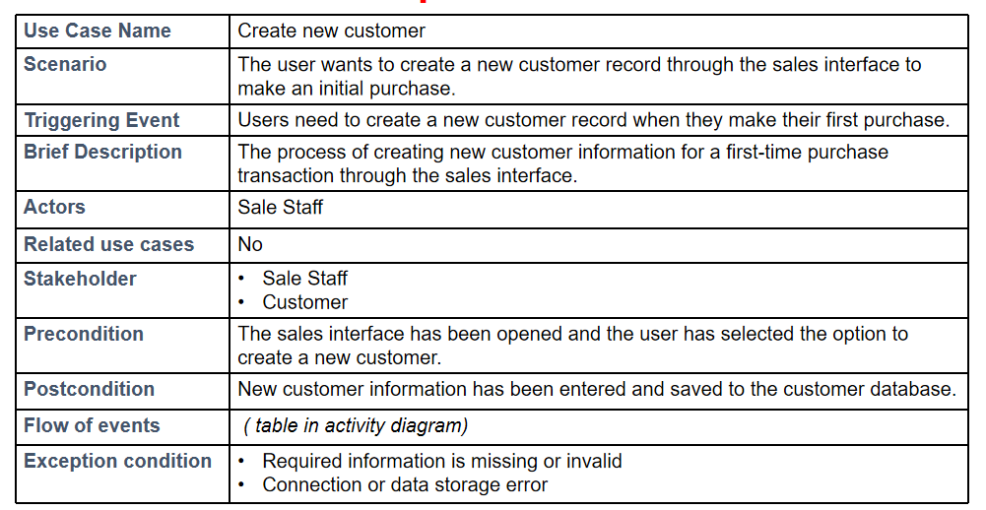

**II. Activity diagram for use case : Create new Customers.**

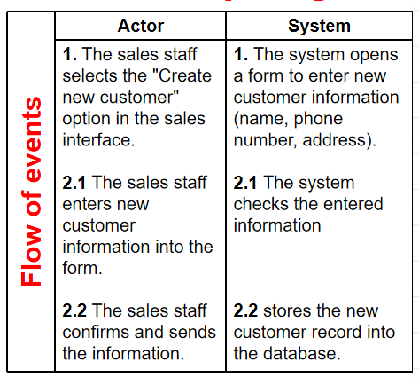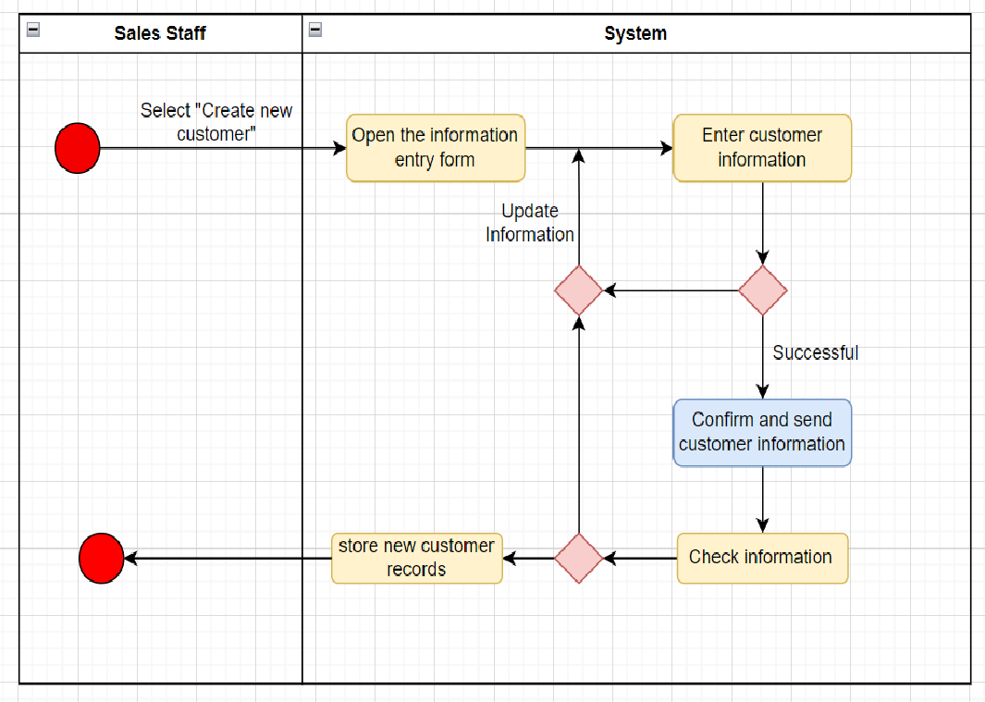

**III. System sequence diagram for use case: Create new customers**

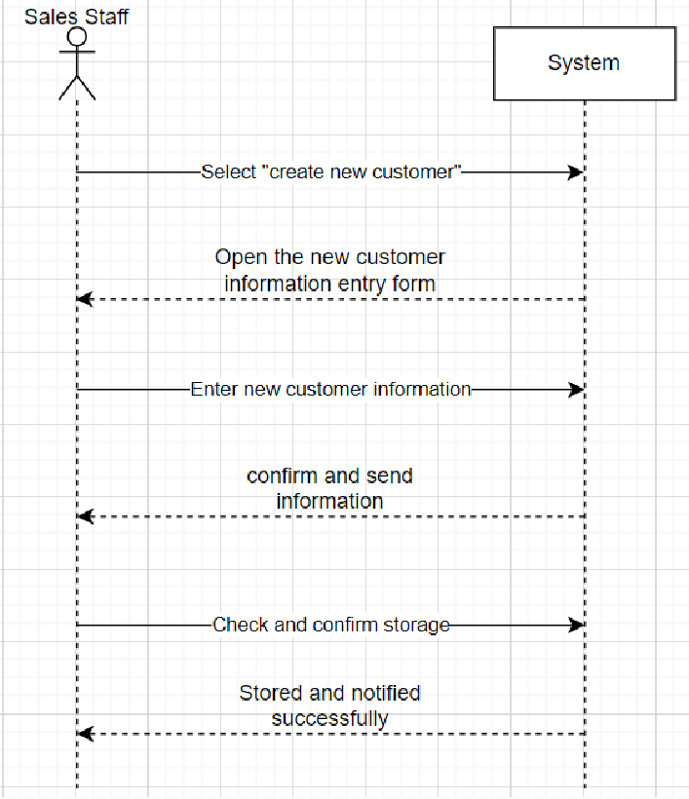

**2.2.2 *Use Case: View Customer***

**I . Use case : View Customer.**

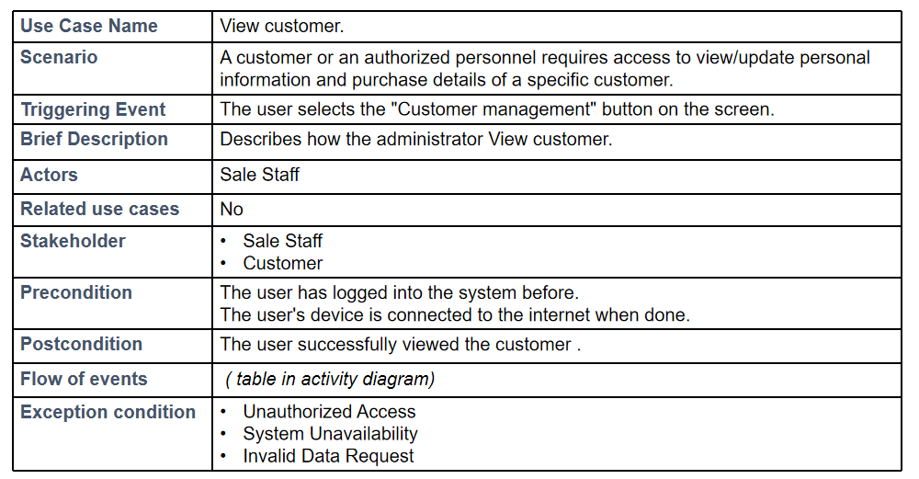

**II. Activity Diagram for use case: View Customer.**

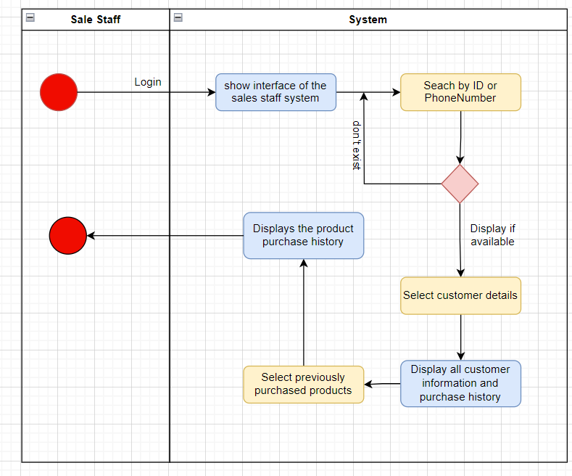

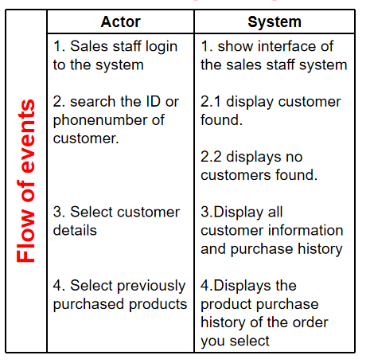

**III. System sequence diagram for use case: ViewCustomer.**

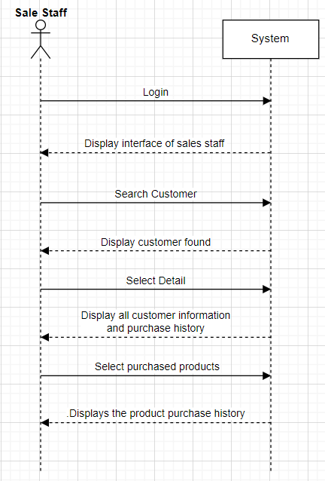

***2.2.3 Use case: View Product List***

**I. Use case: View the product List**

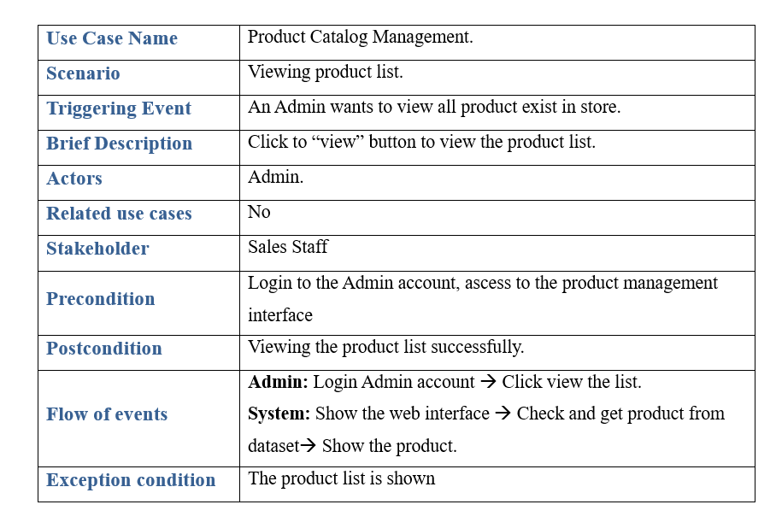

**II. Activity Diagram for use case: View the product List**

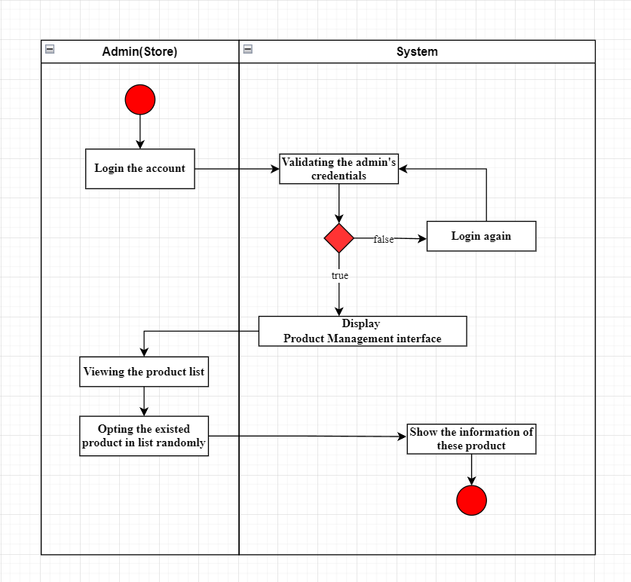

**III. System sequence diagram for use case: view the product list**

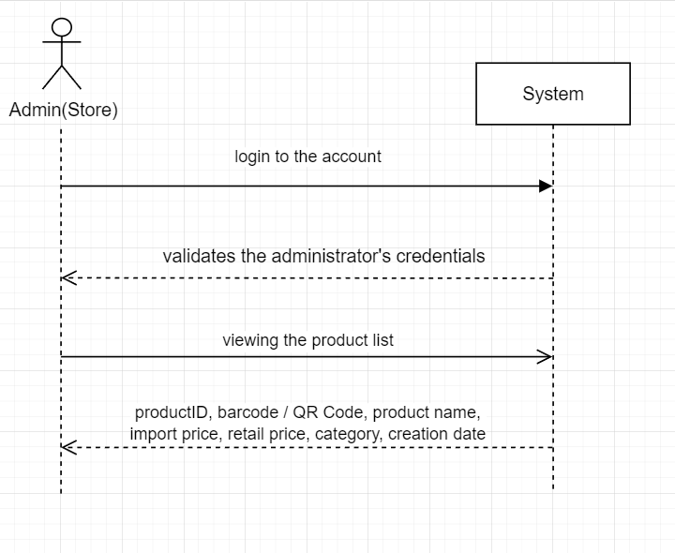

***2.2.4 Use case: Add new product.***

**I. Use case: Add new product.**

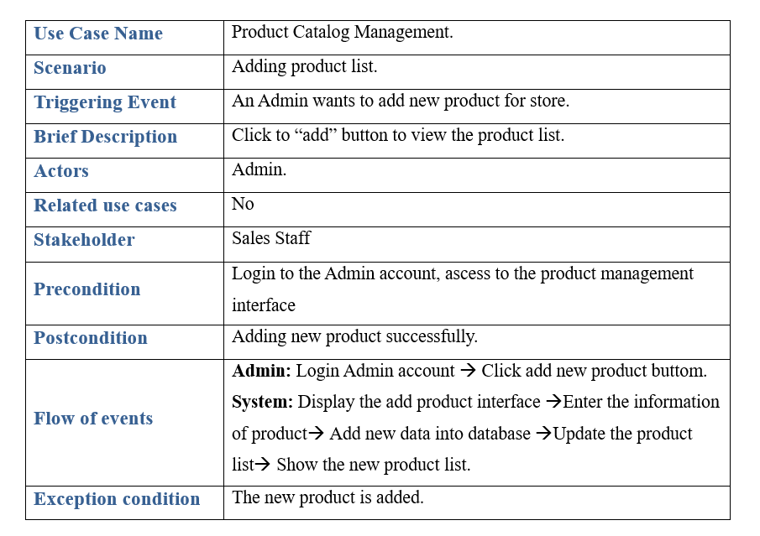

**II. Activity Diagram for use case: Add new product.**

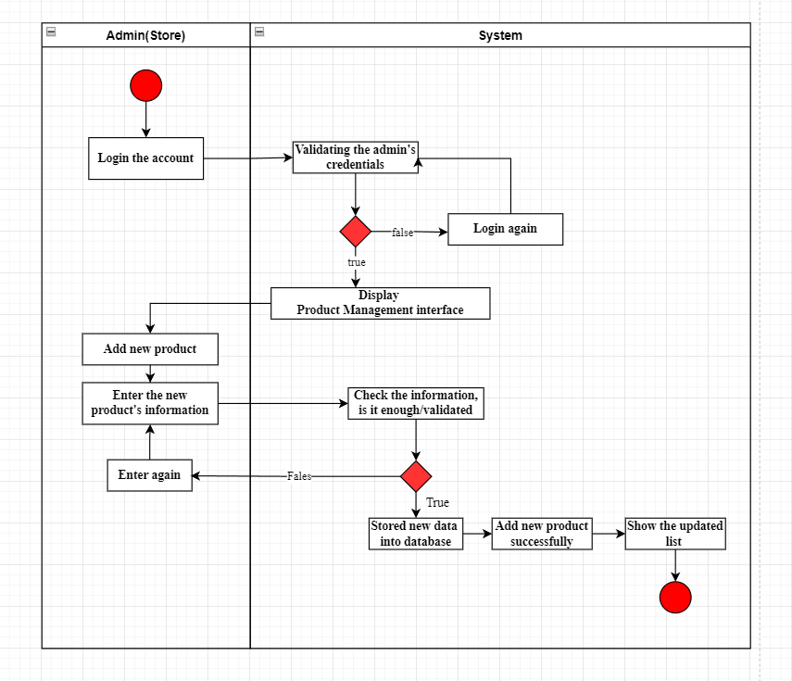

**III. System sequence diagram for use case: Add new product.**

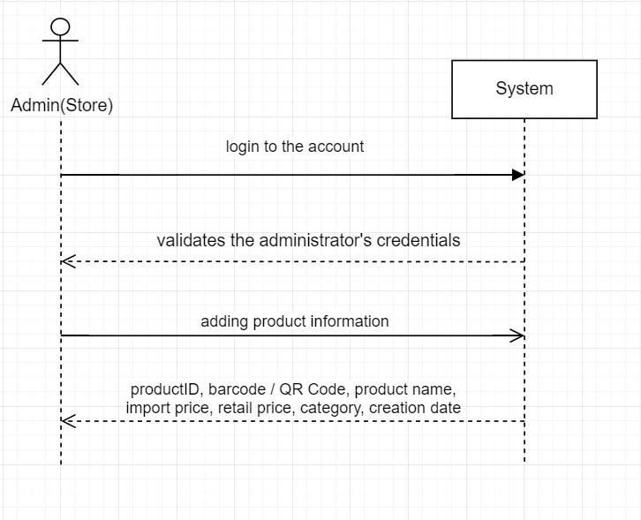

***2.3 Verifying use cases for actor***

***2.3.1 Verifying use cases: Manage Customer for Sale Staff.***

|  |  |  |
| --- | --- | --- |
| **Data entity/domain class** | **C R U D** | **Verified use case** |
| Customer | Create | Create new customer |
|  | Read/report | View product listings (Sales Staff)  View information of customers  View purchase history of customers |
|  | Update |  |
|  | Delete |  |

***2.3.2 Verifying use cases: Manage Product for Store Admin.***

|  |  |  |
| --- | --- | --- |
| **Data entity/domain class** | **C R U D** | **Verified use case** |
| Store Admin | Create | Create Product |
|  | Read/report | View product listings  Manage Sale transactions  Produce transaction summary reports |
|  | Update | Update Product |
|  | Delete | Delete Product |

**CHAPTER 3: System Requirements Design**

**3.1 Design Class for Management Customer.**

**3.1.1 Design Class in Detailed Design.**

Convert Domain Class to Design Classes.

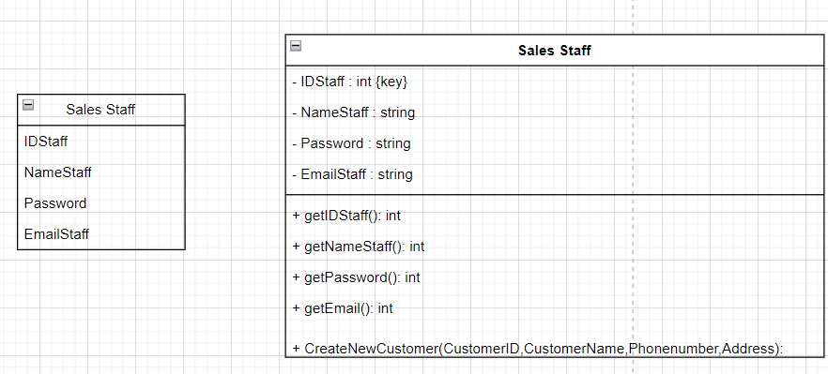

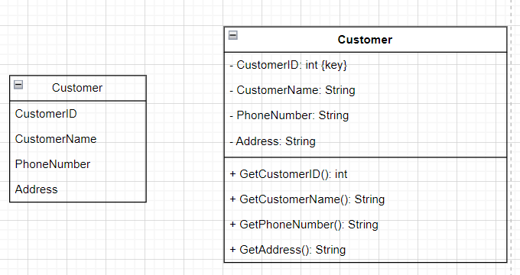

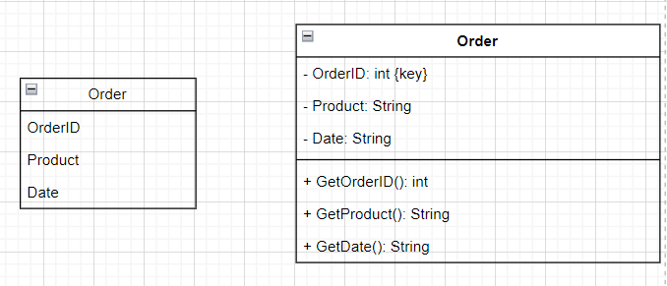

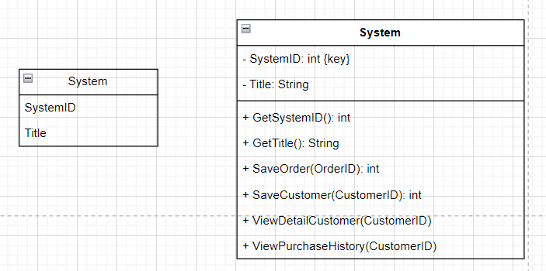

**3.1.2 Design Class Diagram**

I. Domain Design Class

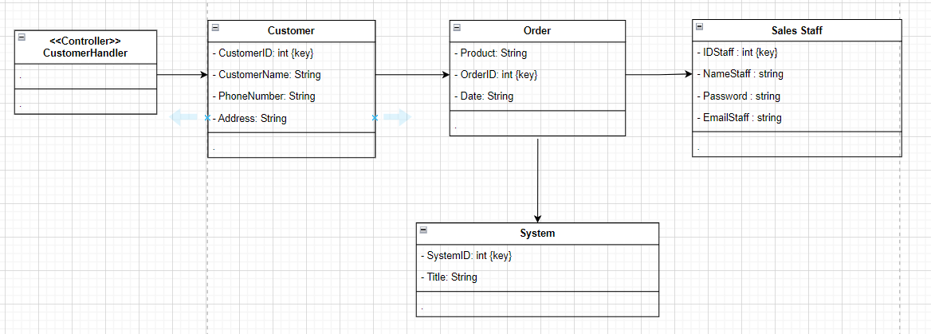

II. Controller

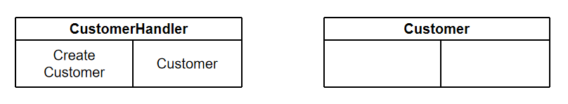

III. UI

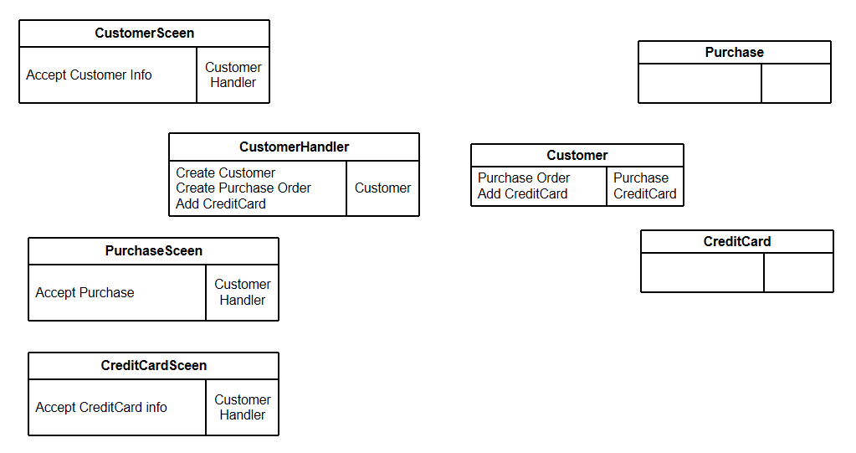

IV. Data Accesss

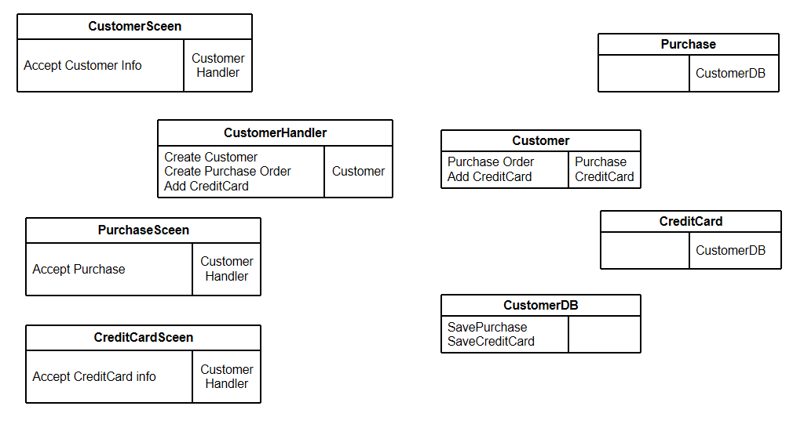

V . Design Class.

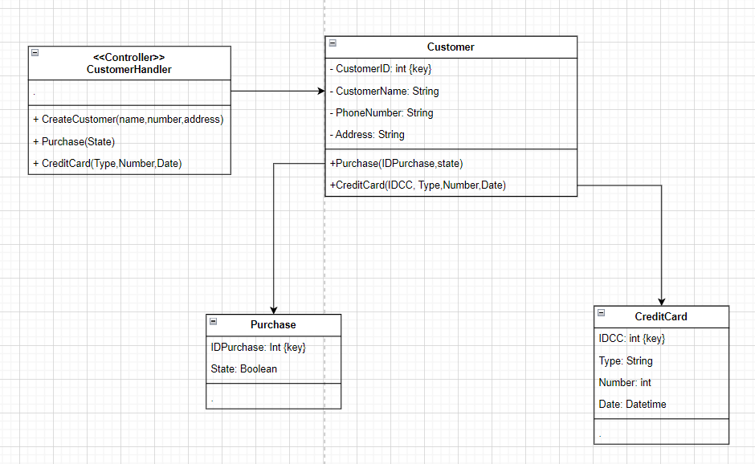

**3.1.3 OOD with Communication**

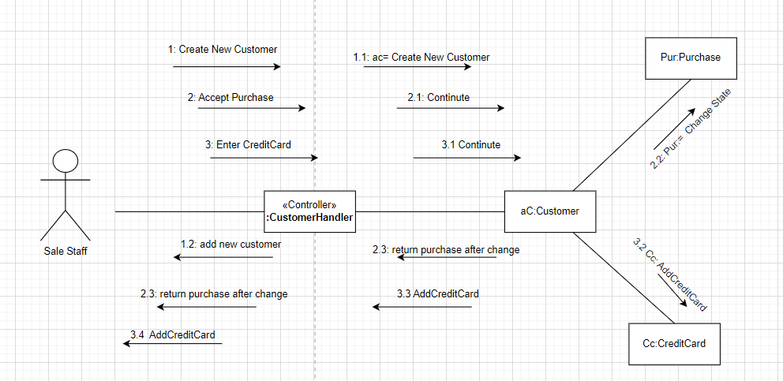

**3.1.4 OOD with Sequence Diagram**

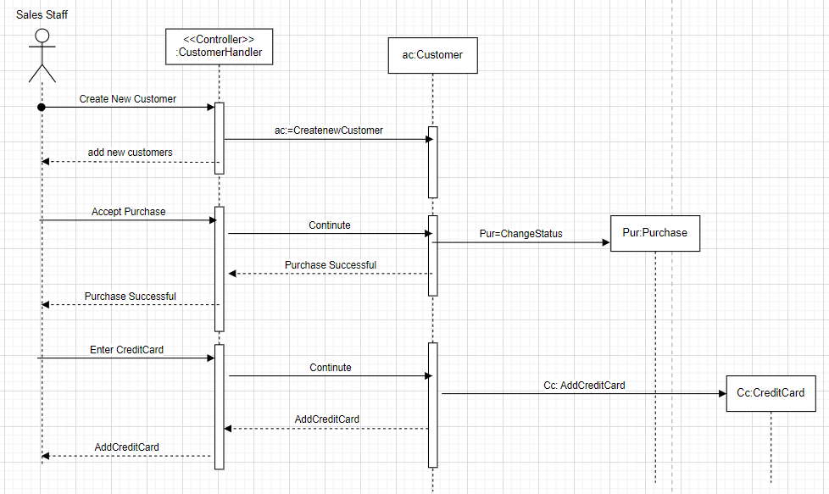

**3.1.5 Final Design Class Diagram**

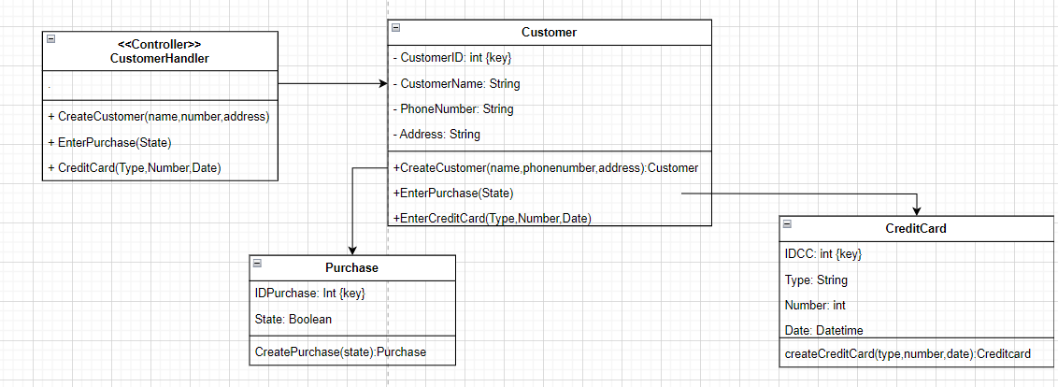

**3.2 Design Class for Product Management**

**3.2.1 Design Classes in Detailed Design**

**3.2.2 Design Class Diagram**

I. Domain design class

II. Controller

III. UI

IV. Data Access

V. Design Class

**3.2.3 OOD with Communication**

**3.2.4 OOD with Sequence Diagram**

**3.2.5 Final Design Class Diagram**

**CHAPTER 4: System Requirements Implementation**

**4.1 Design Class for Sub-System**

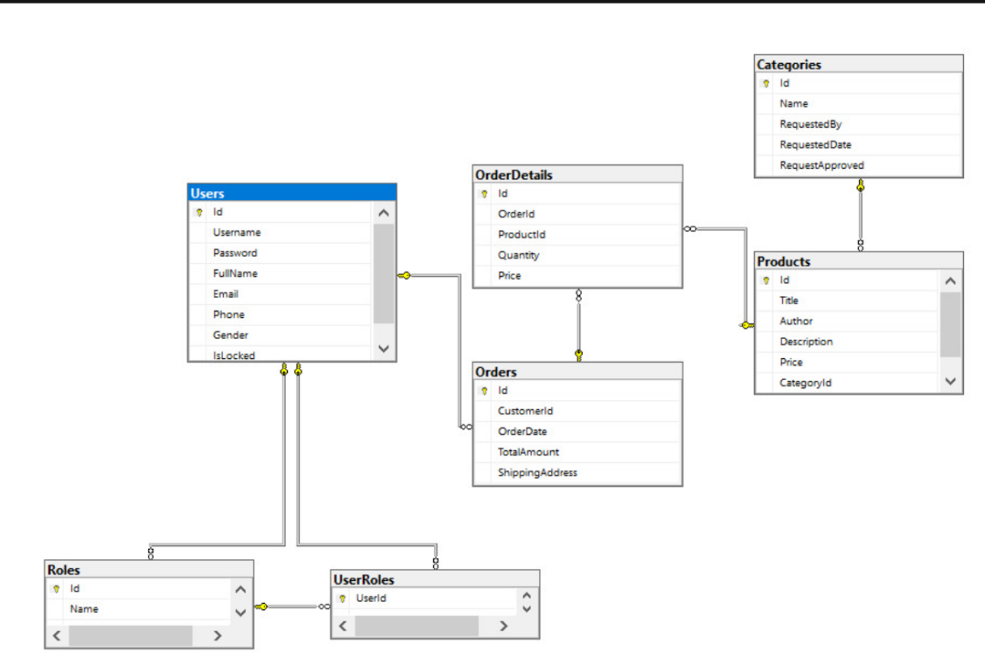

**4.2 Package Diagram for Sub System**

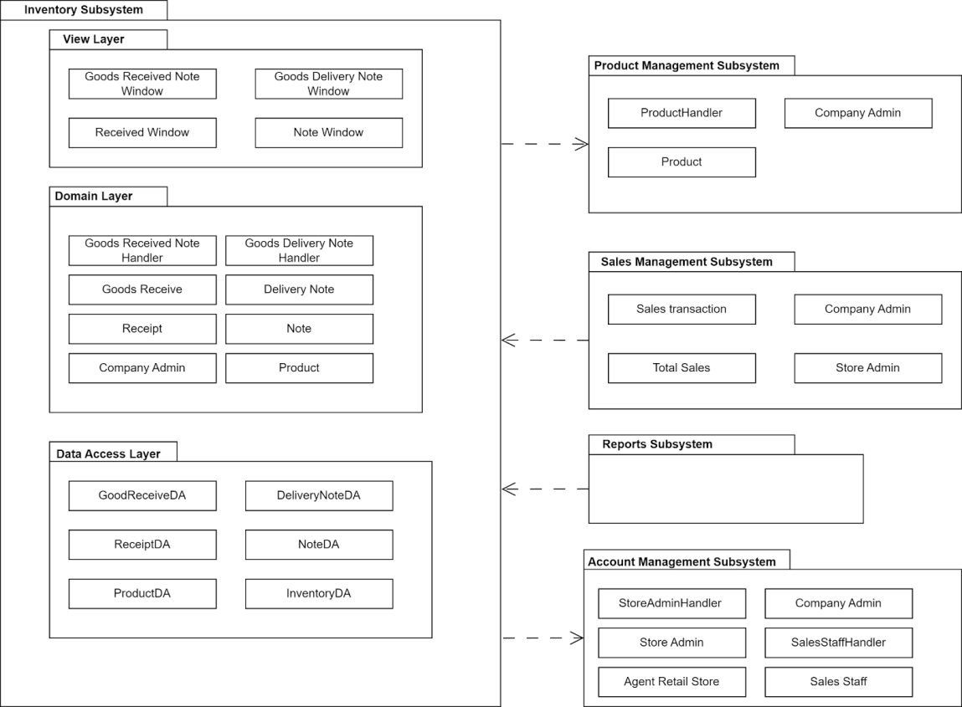

**4.3 Implementation**

**4.3.1 Map persistent objects to the tables in a database**

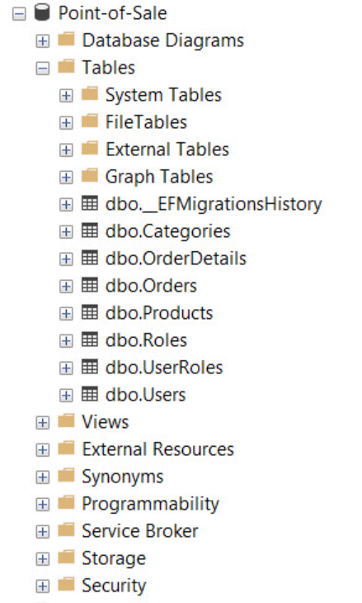

**Dbo.__EFMigrationsHistory**



**Dbo.Categories**

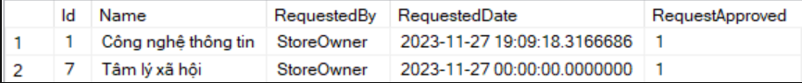

**Dbo.OrderDetail:**

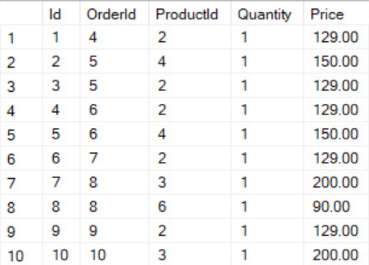

**Dbo.Order**

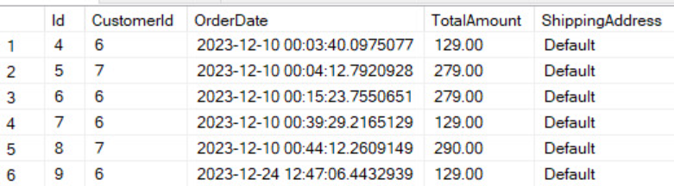

**Dbo.Products**

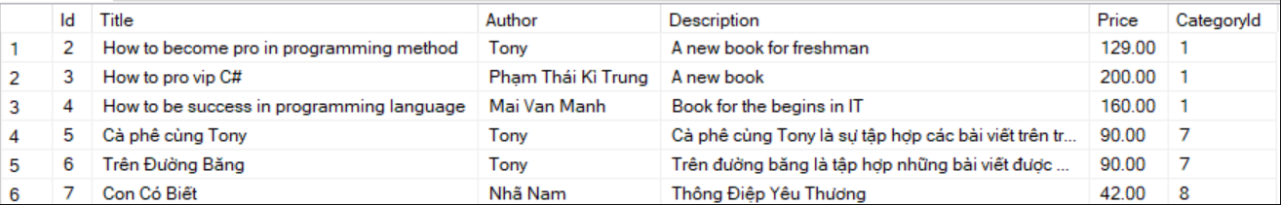

**Dbo.Roles**

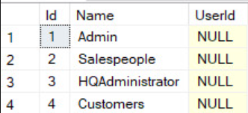

**Dbo.UserRoles:**

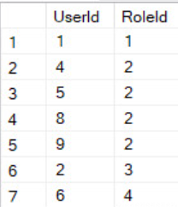

**Dbo.users**

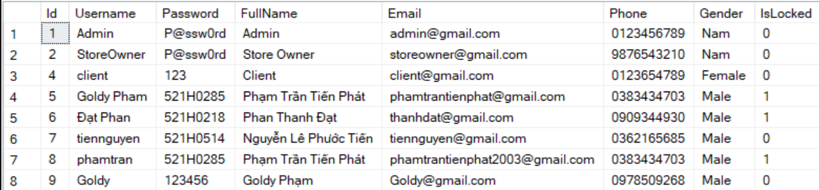

**4.3.2 Modifying sequence diagrams**

**Create Customer:**

**View Customer:**

**Create Product:**

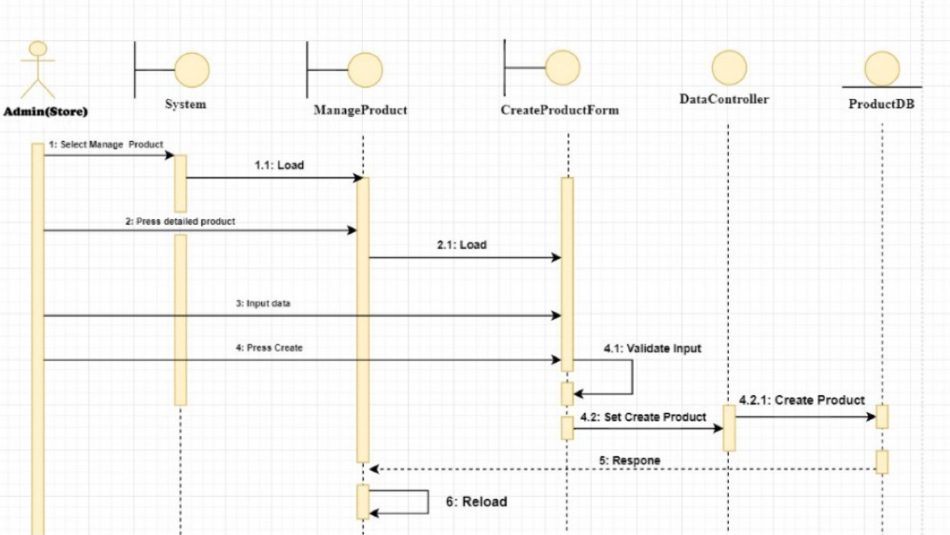

**View Product:**

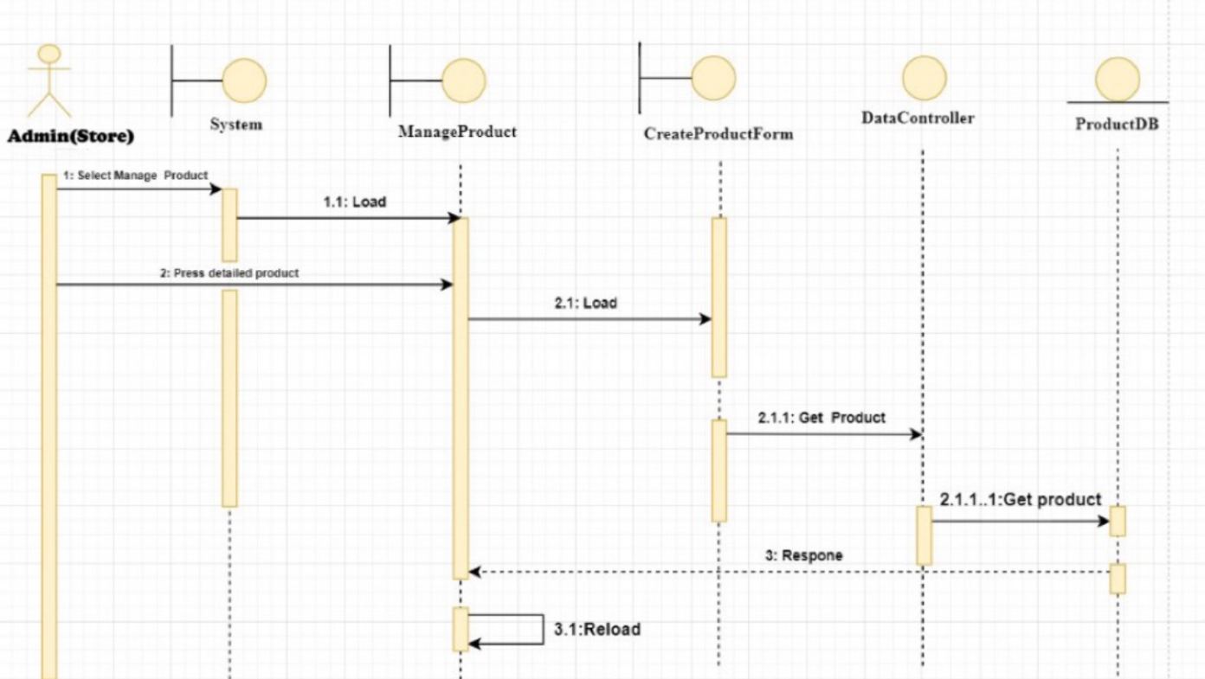

**4.3.3 UI Design**

**4.3.3.1 UI Desgin for use case: Manage Customers**

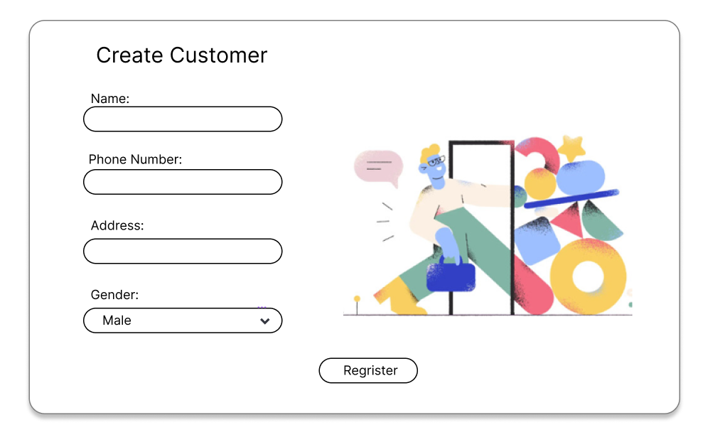

**UI Create new customer**

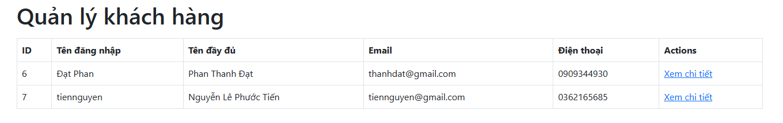

**UI Manage Customer**

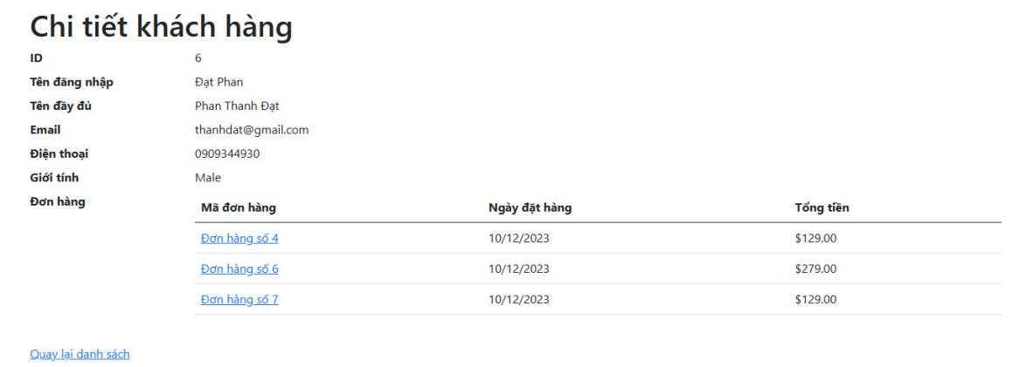

**UI Detail of customers**

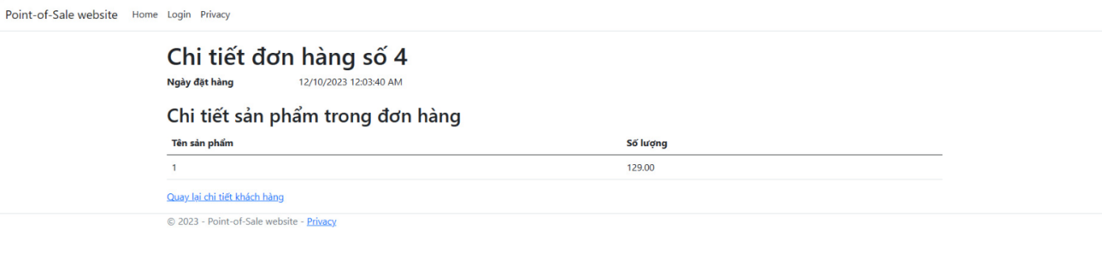

**Detail of order which customers bought**

**4.3.3.2 Use Case: Management Product.**

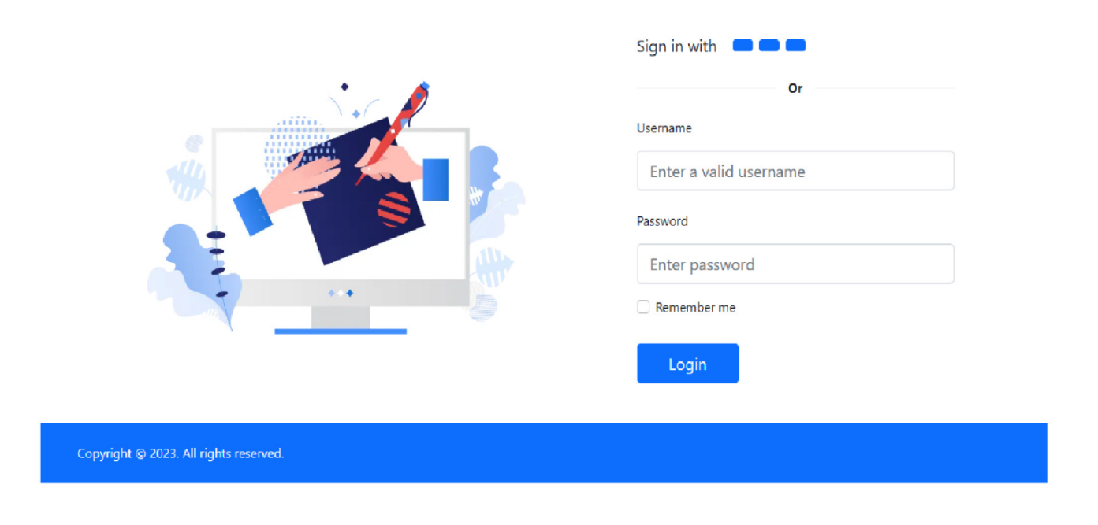

**UI Login of store admin**

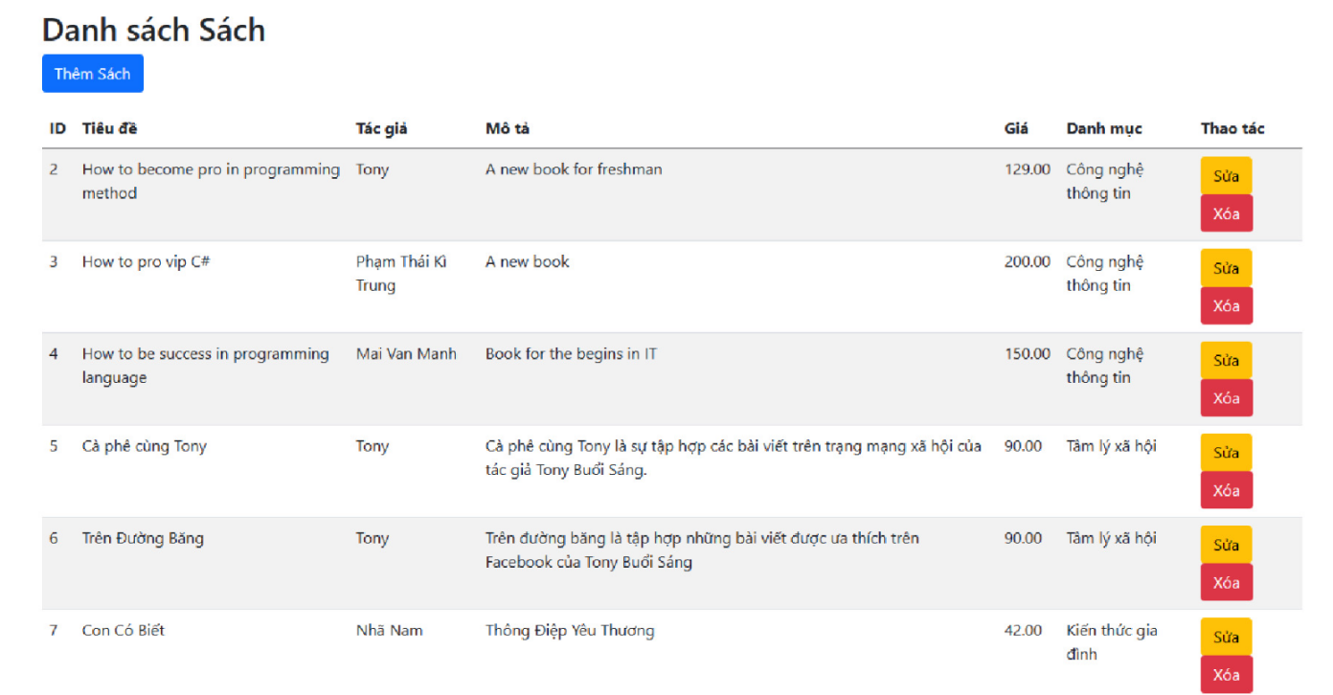

**UI Product.**

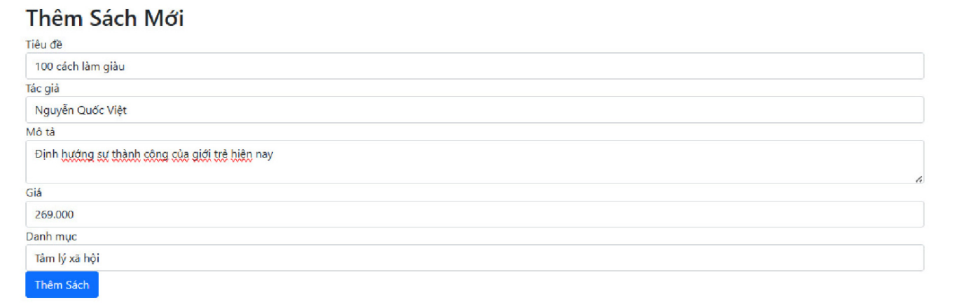

**UI Create Product**

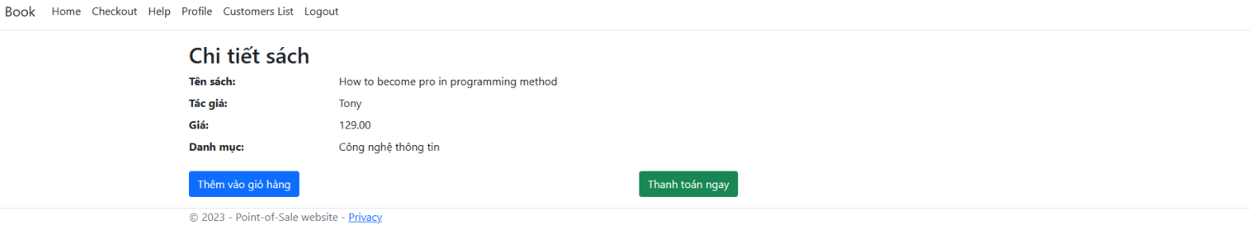

**Detail of product**

**4.3.4 SQL Code**

**I. Create Database**



**II. Create Table**

Because we use Migration in Visual Studio, our database is quite difficult to view.

Table: Categories

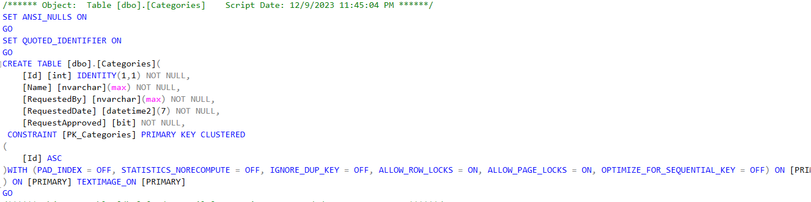

Table: OrderDetails

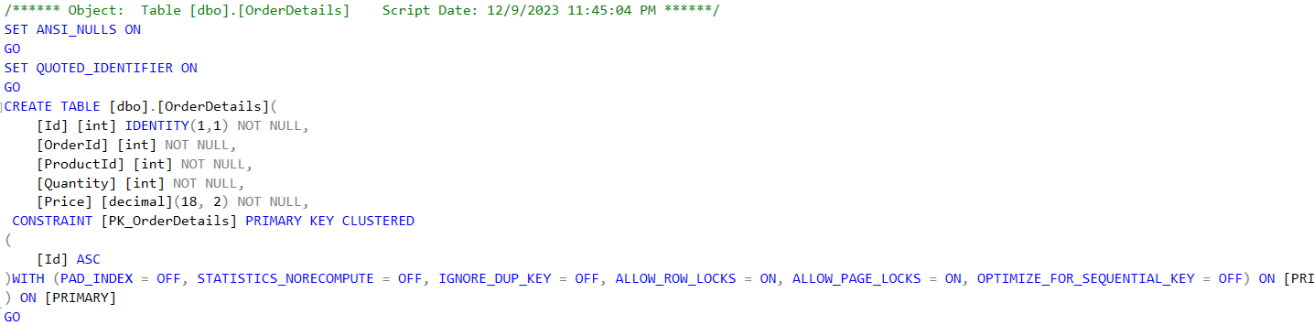

Table: Orders

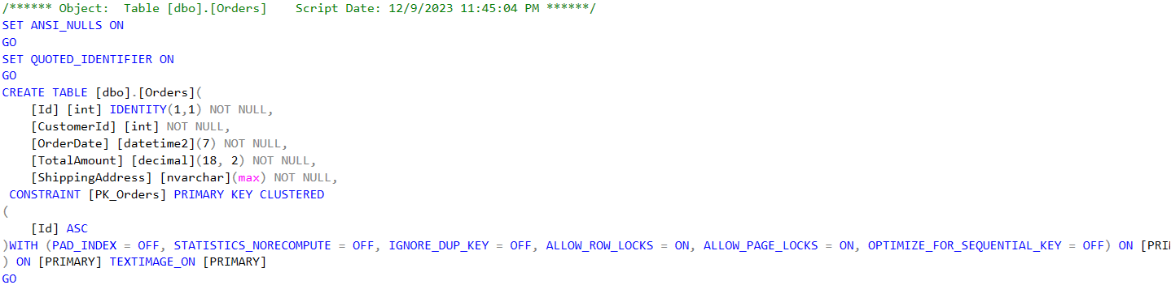

Table: Products

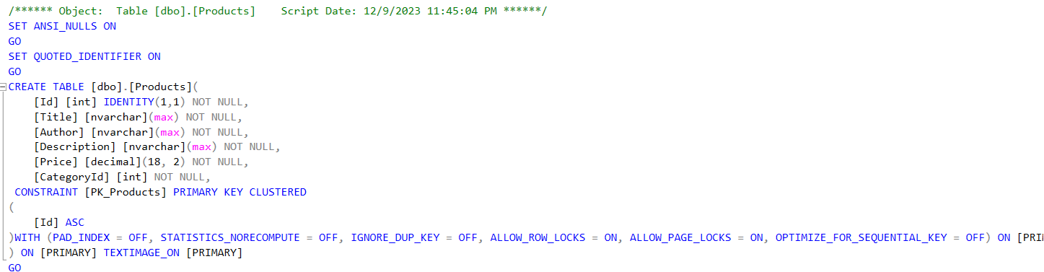

Table: Roles

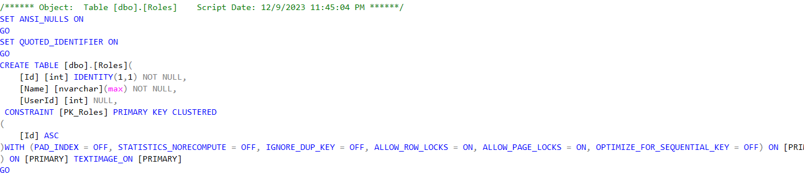

Table: UserRoles

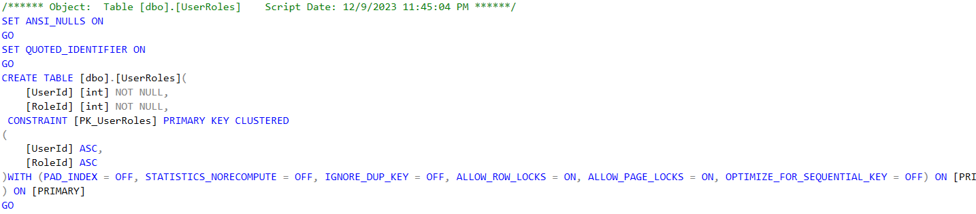

Table User:

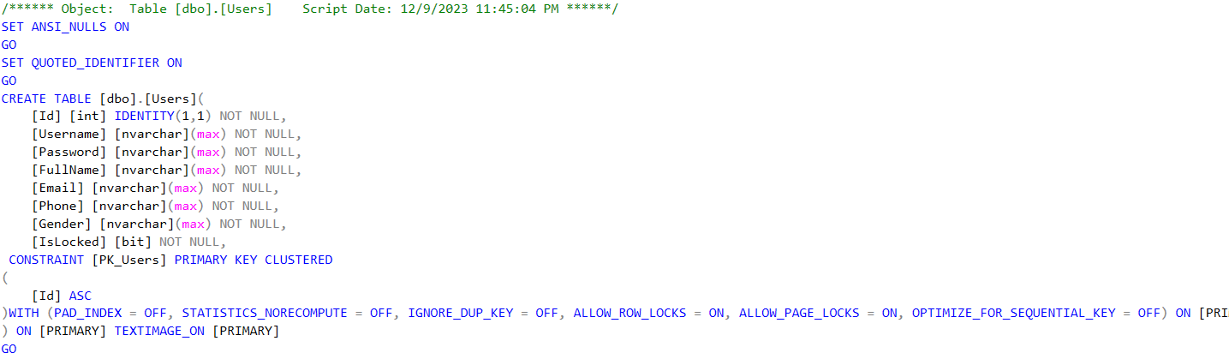

**4.3.5 Software Classes Method Code.**

**Write the Code for the Design Class to Implement by C#**

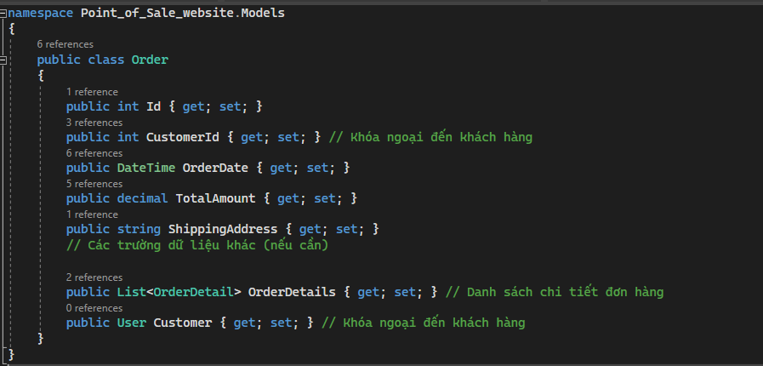

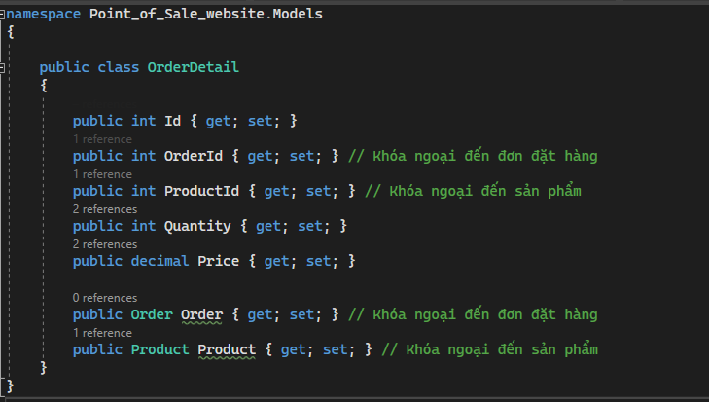

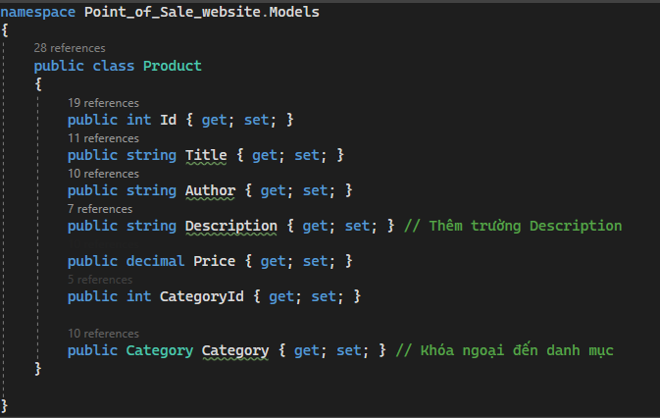

These are just a few typical codes. If you want to see more, please refer to the source code we included when submitting.

**CHAPTER 5: System Testing, Deployment and Demonstration.**

**5.1 Testing: Test plan & Test case**

Test case for use case: Create new customers

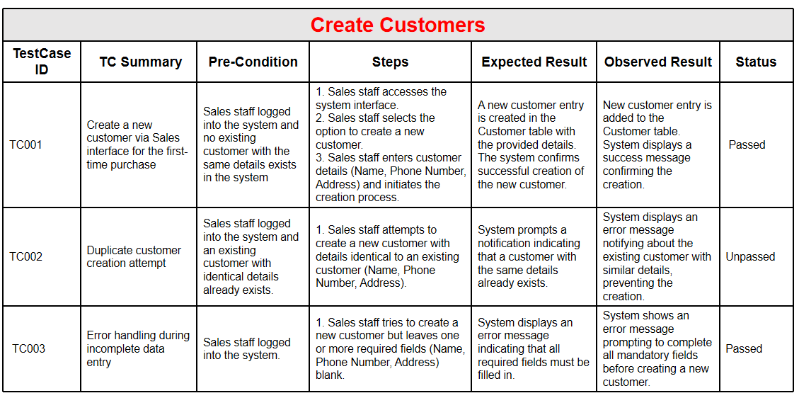

Test case for use case: View Customers.

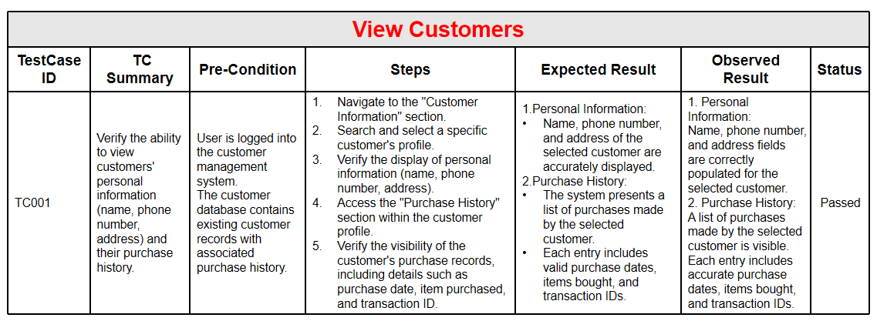

Test case for use case: View the product list and add new product.

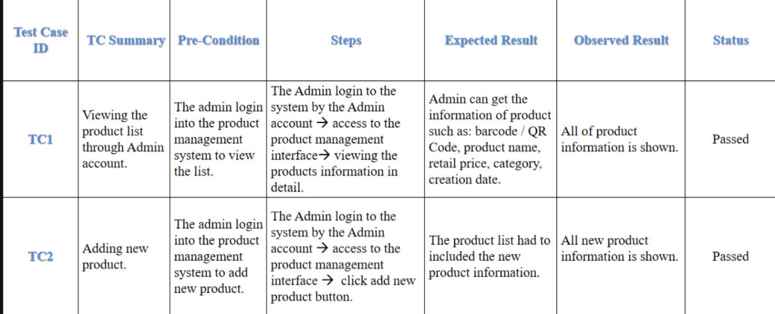

**5.2 Deployment**

**1. Database Setup:**

Create SQL Server Database:

* Develop a SQL Server database to house essential information.
* Design tables for managing accounts, products, customers, sales, and inventory.
* Establish proper relationships between tables to ensure data integrity.

**2. Backend Development (C# with ASP.NET):**

Backend Logic:

* Utilize C# to craft backend logic that manages business rules and interacts with the SQL Server database.
* Implement user authentication and authorization mechanisms using C#.
* Develop classes and methods for managing accounts, products, customers, sales, and inventory.

**3. Web Application Development (ASP.NET Web Forms or MVC):**

Web Forms/MVC Development:

* Design ASP.NET Web Forms or MVC views for managing accounts, products, customers, sales, and inventory.
* Implement role-based access control to limit functionalities based on user roles.
* Incorporate DataGridViews, TextBoxes, and other controls for data interaction and presentation.

**4. Security Measures:**

Secure Coding Practices:

* Apply secure coding practices in C# to mitigate vulnerabilities.
* Implement encryption methods to safeguard sensitive data before storing it in the SQL Server database.
* Regularly update and patch the application to address security loopholes.

**5. Testing:**

Comprehensive Testing:

* Perform rigorous testing, including unit tests and user acceptance testing, to validate application functionalities.
* Draft test cases aligning with various use cases and scenarios.
* Identify and rectify bugs and issues during the testing phase.

**6. Deployment:**

Database Deployment:

* Deploy the finalized SQL Server database schema to the production SQL Server instance.
* Deploy the C# Web Forms/MVC application to the designated servers or hosting environments.
* Ensure correct configuration of connection strings to enable the application's connection to the SQL Server database.

**7. Training:**

User Training Sessions:

* Conduct training sessions for company administrators, retail store managers (administrators), and sales staff on utilizing the C# Web Forms/MVC application.
* Create user manuals and comprehensive documentation to serve as a reference guide.

**8. Monitoring and Maintenance:**

Scheduled Maintenance:

* Establish a routine for regular maintenance, including updates, bug fixes, and enhancements.

**9. Documentation:**

Thorough Documentation:

* Document the C# codebase, SQL Server database schema, and deployment procedures for future references and maintenance.
* This adaptation reconfigures the provided steps into a structure suitable for implementing WebRTC functionalities using C# and ASP.NET, emphasizing the development of a web-based application.

**5.3 Demonstration**

You can watch the DEMO in :

**https://www.youtube.com/watch?v=UQF7ZiUKj9U**

**CHAPTER 6: Conclusions/ Recommendations**

The development of a Point-of-Sale website tailored for Agents’ Retail Stores offers a cohesive and centralized solution for managing diverse operations. It streamlines account, product, customer, sales, inventory management, and reporting functions, fostering enhanced efficiency, control, and transparency across the company's retail ecosystem. By enabling specific roles and access levels, the system ensures that functionalities are appropriately accessible and hidden as per the user’s role, thereby optimizing operational workflows and security measures. This comprehensive suite empowers retail store agents with the tools necessary for successful operations while providing the company with critical insights and control over its distributed retail network.